1. Running Sum of 1D Array:
#CODE:
class Solution {
public int[] runningSum(int[] nums) {

int sum = 0;

for (int i = 0; i < nums.length; i++) {
sum = sum + nums[i];
nums[i] = sum;
}

return nums;
}
}

OUTPUT:
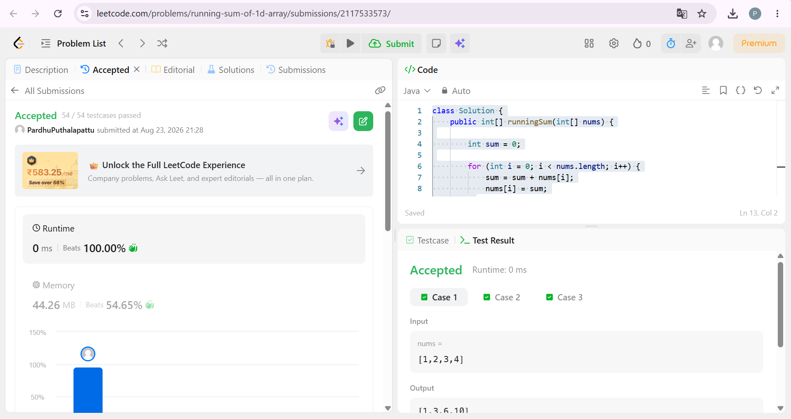

2. Richest Customer Wealth:
#CODE:
class Solution {
public int maximumWealth(int[][] accounts) {

int maxWealth = 0;

for (int i = 0; i < accounts.length; i++) {

int wealth = 0;

for (int j = 0; j < accounts[i].length; j++) {
wealth = wealth + accounts[i][j];
}

if (wealth > maxWealth) {
maxWealth = wealth;
}
}

return maxWealth;
}
}

OUTPUT:
